Information about 3 Anti-Immigrant Bills Introduced in the Wisconsin State Legislature
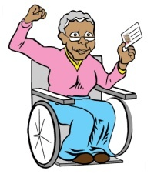
- SB 533 – a bill to block local control and local IDs, co-sponsored by Rep. Sanfelippo (Republican – West Allis) and Sen. Wanggaard (Republican – Racine and Kenosha Co.). – A bill to prevent the City of Milwaukee and Milwaukee County from creating local ID cards.
This bill would:
- Prevent the City of Milwaukee and Milwaukee County from creating ID cards for undocumented people and those who lack the documents to obtain a state ID. It would prevent other counties from doing the same.
- The city could distribute local IDs, but the cards would have to say “Not for Voting” on them. Also, people could not use the cards in any way when applying for social safety net programs like food stamps.

Our analysis:
- This bill is an escalated attack on local control that not only impacts Milwaukee but threatens other counties throughout the state. For the first time, the state is dictating to counties what they can and cannot do with their own resources, regardless of the needs of the local community.
- This bill is a bigoted attack on immigrants, transgender people, the homeless, seniors, formerly incarcerated people and the thousands of low income people in Milwaukee and throughout the state who cannot access Wisconsin state ID.

With Milwaukee IDs, vulnerable people will:
- Be able to identify themselves to police when stopped or when they need to report crimes, making everyone safer
- Be able to identify themselves to homeless shelters, healthcare providers, and other institutions.
- Be able to open a bank account and cash checks.
- Domestic violence survivors will be able to file papers in court to protect themselves and their children.
- Have access to local services they pay taxes to provide, like city recycling centers.
- Enter public schools to meet their children’s teachers.
- Transgender people will have an ID that agrees with their identity.
- The ID cannot be used as identification for voting or to access social safety net programs.

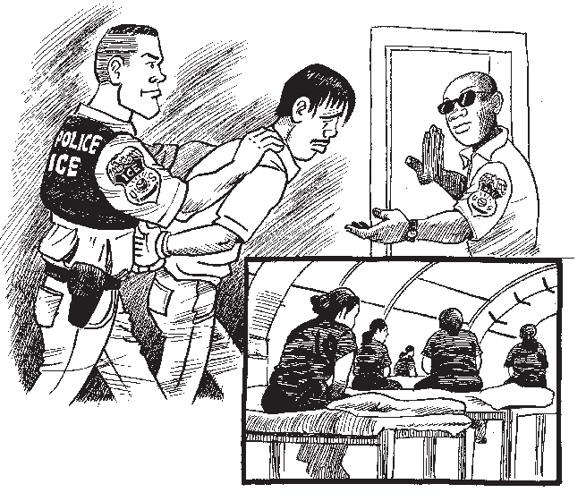
- AB 450 - Anti-Sanctuary City Bill, sponsored by Rep. Spiros, Sen. Nass, and many others.

This bill would:
- Permit police and public employees to ask people who have been charged with a crime including not paying tickets or driving without a license about their immigration status and detain them for ICE.
- Prohibit the police and local government agencies from creating policies that prohibit employees from asking members of the public about their immigration status or from collaborating with ICE to the maximum extent.

Our analysis:
- Because it would lead to increased collaboration between ICE and police, the bill would make undocumented victims of crime, domestic violence survivors, and their loved ones afraid to contact the police. We are all less safe when thousands of community members are afraid to report crimes.
- The bill encourages racial profiling and aims to turn every local police officer, courthouse clerk, and city worker into an ICE agent.
- We need to advance policies that build trust between communities of color and the police. We need to completely separate local law enforcement from ICE. The job of local police is to keep us safe, not deport community members.
- This type of policy has been discredited. Hundreds of cities and states nationwide have passed laws limiting or ending collaboration between ICE and local police. This wave of opposition led to the November 2014 directive from President Obama limiting the circumstances in which police can detain people for ICE. AB 450 takes us backward.

- Bill to impound the cars of people driving without a license, or driving on a suspended license or revoked license – By Rep. Sanfellipo (Republican – West Allis).
This bill would:
- Would require police to immediately impound the car of anyone stopped for driving without a license or driving on a license that is revoked or suspended.
- To retrieve your car from the impound lot, you would need to be the owner and have a license and proof of insurance. Also the car would have to be registered.
- People would have to have a Driver License to register their car with the DOT.

Our analysis:
- Instead of supporting legislation to provide driver licenses to undocumented people and to make the roads safer, this law tries to make life so difficult for immigrants and Latinos that they are forced to leave Wisconsin, as happened in Arizona after the passage of SB 1070.
- This law will encourage some police to engage in racial profiling. Latinos already are victimized by racial profiling in traffic stops. Some police rail drivers who look Latino, look up their plates, and pull them over if they think they don’t have a license. This bill will encourage police to intensify their efforts to stop unlicensed drivers.
- Rep. Sanfelippo says his bill is about getting drunk drivers off the road but this bill would not impound the cars of drunk drivers.

